Individual Logbook

Week 15
Dave Sushames
2026
Contents
Table 1
Discussion 1

Table
Category | Hours Completed
Team meetings | 3h 30m
Client meetings
Advisor meetings | 1
Research
Development
Testing
Documentation | 13
Logbook preparation | 1
Other | 8
Total hours for this week | 26h 30m
Running total of hours completed for Capstone | 410h 15m

Logbook content notes
Team meetings:
Monday 10-12:30: Auditing logs, collating logs into group timesheet, progress check on all the documents due this week
Tuesday 10-11: Team meeting where we discussed work needed. Looked at the poster, the team decided the new colour scheme was bad, so we picked new colours. Also decided that we needed some new graphs that included the setup time for the LLM scripts.
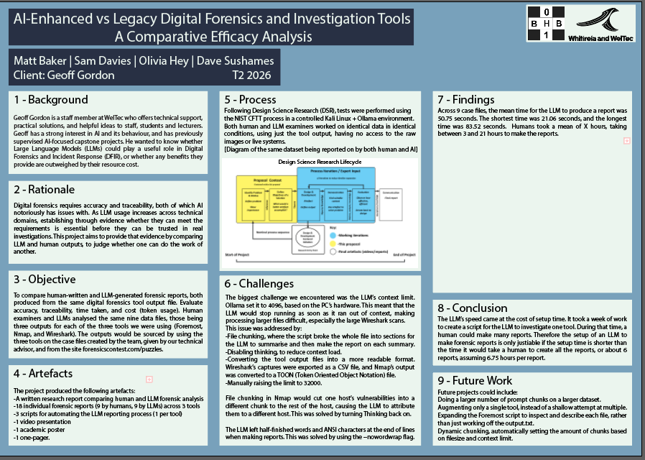
Client meetings:
Advisor meetings:
Tuesday 9-10: Bryce meeting
Research
See research log
Development
Documentation
Monday 8:30-9:15: Going through the Client Closeout Report, doing a final cleanup. Checking for spelling mistakes, formatting issues, making sure its all using the same font.
Monday 9:15-9:45: Working on the poster, fixing inconsistencies with the Research Report.
Monday 1:30-6 Working on the poster. Selecting a new colour theme, rewriting Challenges section to include the file chunking/thinking issue. Had to make sure it all fit into the section, there was only so much I could stretch the boxes without pushing into the Process section. Divided the three panels into multiple parts, for easier viewing. Added new WelTec logo and group logo.
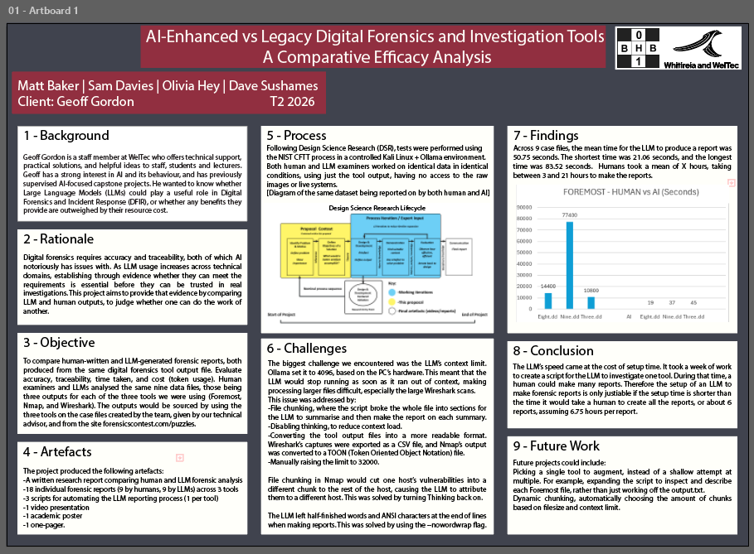
Tuesday 11-12:30: Figuring out how to make Break-even charts, to show the setup time for LLM scripts. Got Matt to find out how long taking the script *actually* took, rather than “about a week”. Turns out its about 21 hours.
Tuesday 1:30-3:45: Figuring out how to add a crossover point and get Excel to show it in the graphs, as well as making a fourth, Average graph. 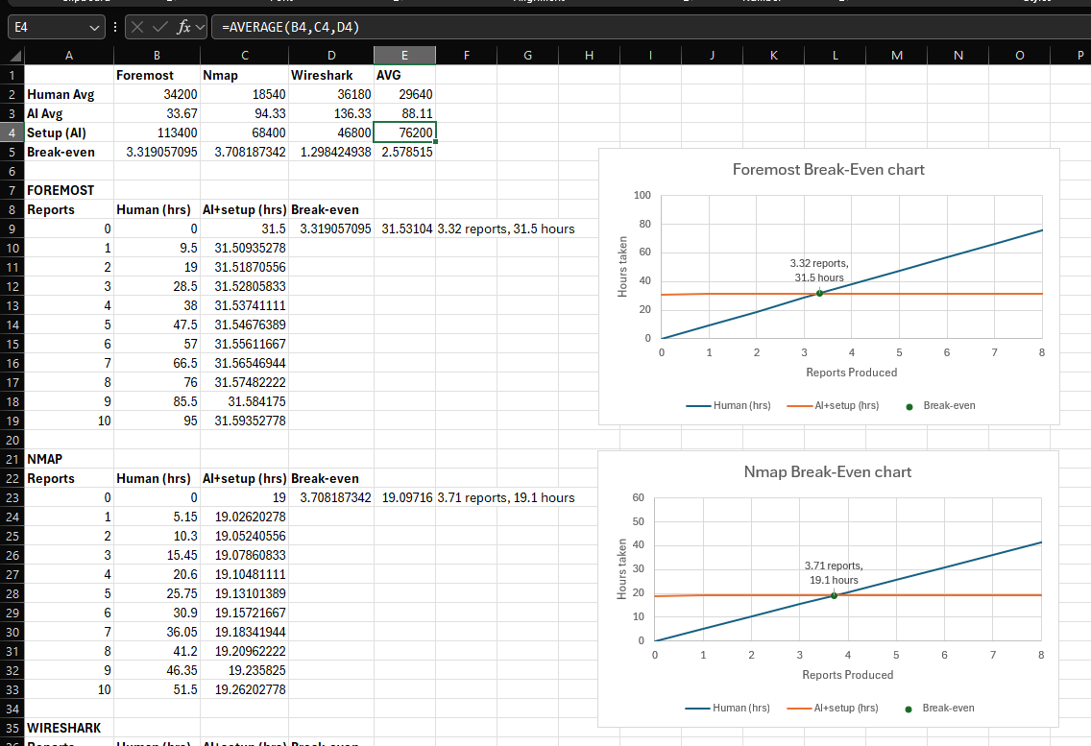 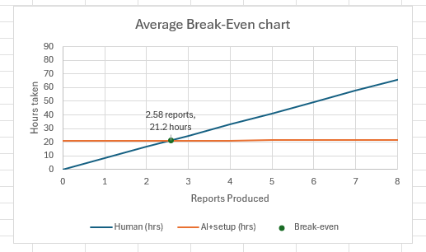
Tuesday 3:45-5:45: Looking at the One-pager, where Olivia had highlighted bits that need work, due to either poor wording or inaccuracies in the information. Fixed the sections in Introduction and Development. Updated the onepager and research document with the new 21 hours development time, and added the Break-even chart to the Poster.
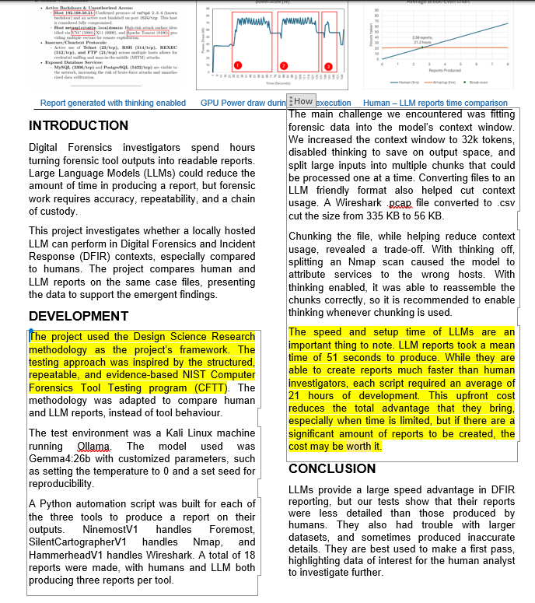
Wednesday 10:30-12pm: Finishing the poster. Filling out the final bit of the Findings section and the conclusion.
Other:
Six hours of panel prep, and two hours of actual panel presentation.

